**Isuzu D-MAX 250  HI-RIDE 4X2**

***Manual From R461 100 Incl VAT***

***Automatic From R480 400 Incl VAT***

**Isuzu D-MAX 250 LE Auto From**

***R501 500 Incl VAT***

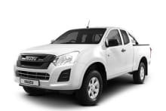

**Isuzu D-MAX 250 X-Rider 4X2**

***Manual From R508 100 Incl VAT***

***Automatic From R527 400 Incl VAT***

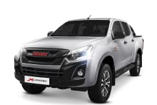

**Isuzu D-MAX 250 D-TEQ X-Rider 4x4**

***From R565 200 Incl VAT***

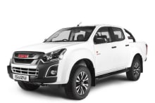

**Isuzu D-MAX 300 D-TEQ LX 4x2 M/T**

***From R617 200 Incl VAT***

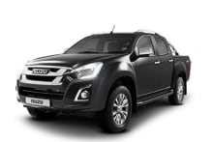

**Isuzu D-MAX 300 D-TEQ LX 4x2 Auto**

***From R635 000 Incl VAT***

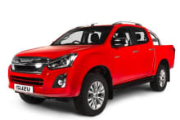

**Isuzu D-MAX 300 D-TEQ 4x4 Auto**

***From R713 900 Incl VAT***

